
つくば機能植物イノベーション研究センター
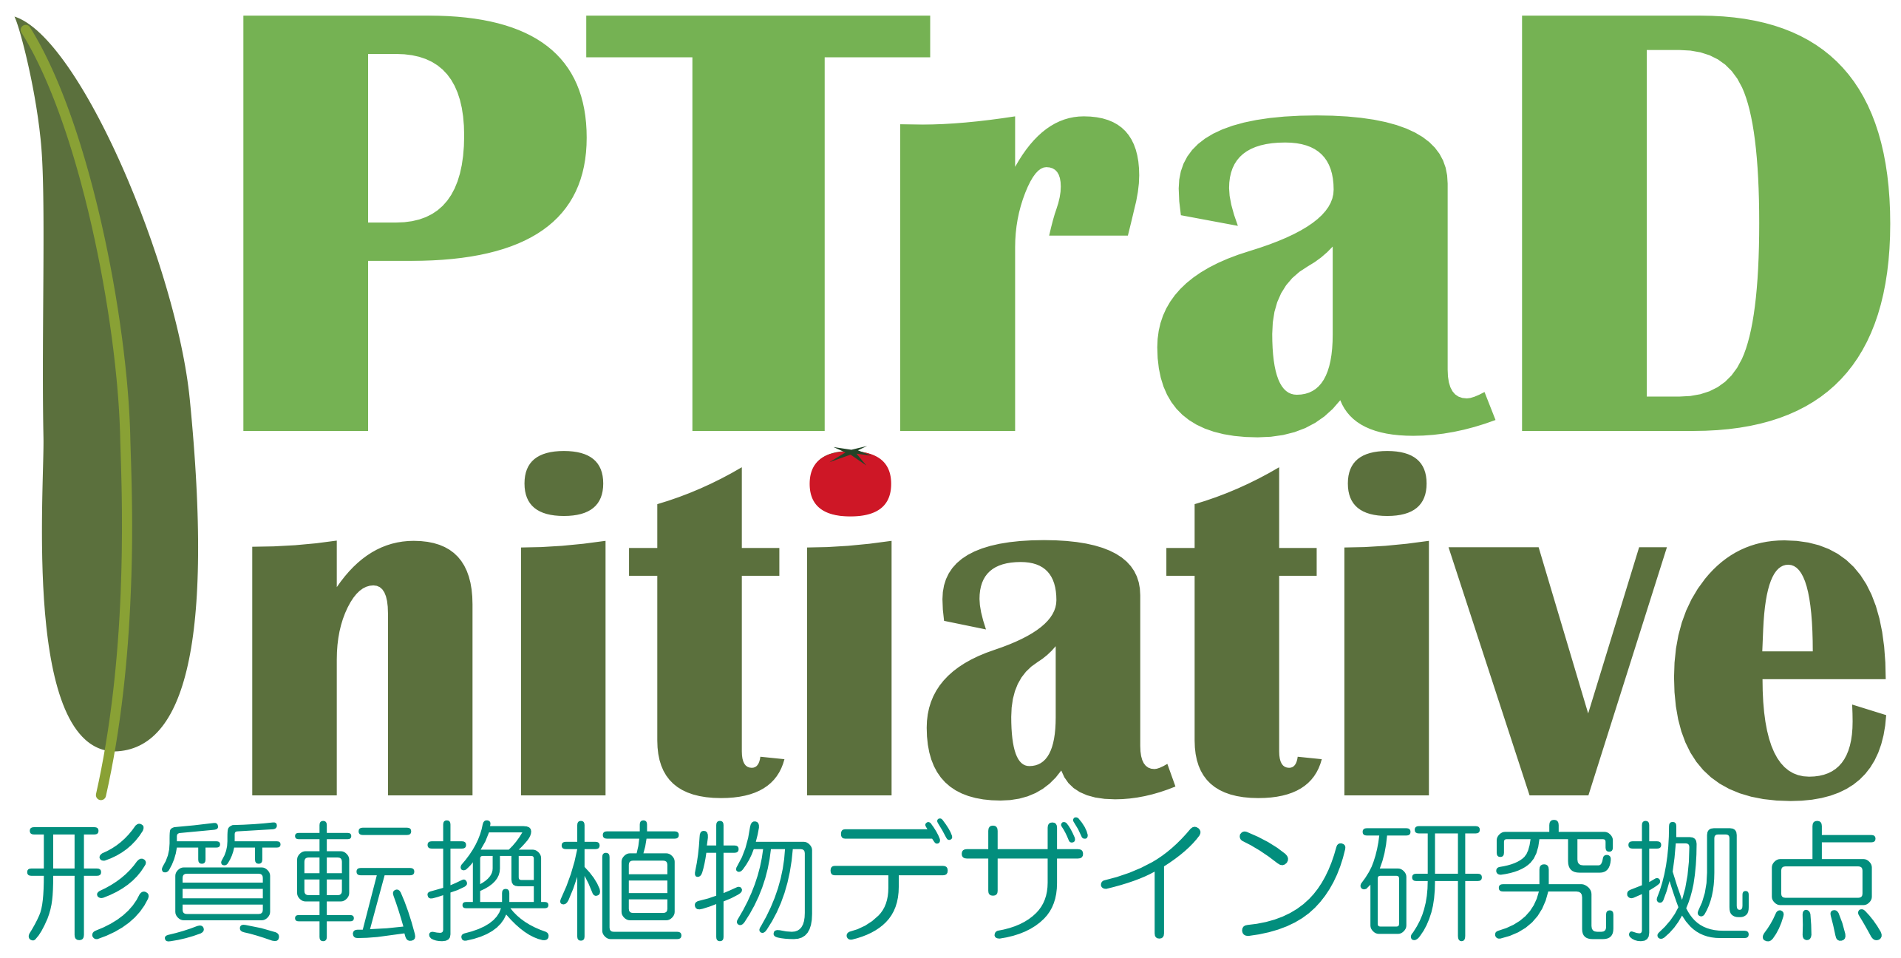
形質転換植物デザイン研究拠点研究セミナー
(88)

日時 : 2026年7月16日（木） 16:00-17:00
場所 : 遺伝子実験センターセミナー室
タイトル : Integrating OMICS Technologies for Crop Improvement: A Focus on Buckwheat Research at SKUAST-Kashmir INDIA

講演者 ： Dr. Sajad Majeedd ZARGAR
Sher-e-Kashmir University of Agriculture Science & Technology of Kashmir, INDIA
※ 2026年7月: JST-LOTUSによる招聘（外国人受託研究員）
Abstract.
Omics technologies have become a cornerstone of modern molecular biology, providing powerful tools to decipher complex biological processes. Over the past several years, our research group at Sher-e-Kashmir University of Agricultural Sciences and Technology of Kashmir (SKUAST-Kashmir), India, has focused on buckwheat to better understand its biology and facilitate its genetic improvement. Our research began with the collection of buckwheat germplasm from the northwestern Himalayas of Jammu and Kashmir, India, leading to the establishment of a genetically diverse core panel. This valuable genetic resource has been extensively evaluated for economically important agronomic traits, nutritional and nutraceutical traits, marker–trait associations, and the identification and validation of bioactive compounds with potential health benefits. Our current research aims to unravel the epigenetic mechanisms underlying buckwheat and their role in enhancing its nutraceutical value.
I would like to sincerely acknowledge the Japan Science and Technology Agency (JST) for supporting my graduate student through the LOTUS (India–Japan Fellowship) Programme. This fellowship enabled her to undertake a part of her PhD research at the Institute of Life and Environmental Sciences, University of Tsukuba, and has also lead to fostering valuable scientific collaboration between India and Japan.

世話人: 三浦 謙治 (T-PIRC)

