2023
National University Corporation
University of Tsukuba
Tsukuba -Plant Innovation Research Center

"Plant Transgenic Design Initiative (PTraD)" Joint Usage and Joint Research Project

Additional Application Guidelines

The Tsukuba Plant Innovation Research Center (T-PIRC) of the University of Tsukuba has been certified joint usage/research center project entitled "Plant Transgenic Design Initiative (PTraD)" by the Ministry of Education, Culture, Sports, Science and Technology since 2010, and has developed a transformative plant design base business that combines basic research on plants and basic technologies related to the development of genetically modified plants. In order to conduct basic research on transformation technology, which is considered a bottleneck for building collaboration and practical application between related fields, field research on transformed plants, and environmental risk assessment research in an integrated manner, joint usage/joint research projects are publicly solicited from related research communities, and are selected and implemented.
In the 3rd phase of PTraD since 2022, in addition to joint research that contributes to the further progress of basic and applied research on plant genes and the promotion of internationalization, we will work on a project for joint research on social implementation research using isolation fields, special netted-houses, and fields that T-PIRC possesses for the development of varieties using new plant breeding technologies including genome editing technology and their social acceptance.
Based on this, we are now accepting applications for joint research in FY2023.

If you have any questions, please contact us by e-mail at the following address.

E-mail: ptrad@gene.tsukuba.ac.jp

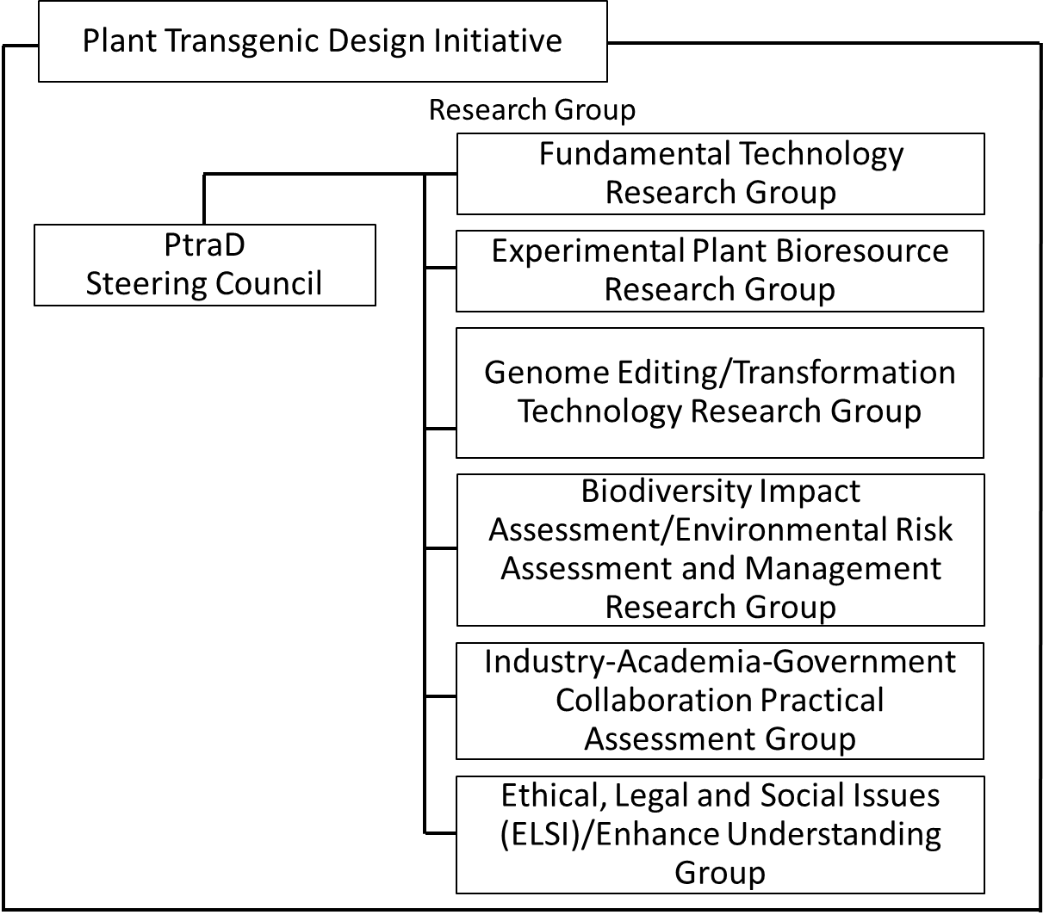

１．Joint Usage and Joint Research Themes to be Publicly Solicited

- Fundamental Technology Research Group [Research Group Leader: Hiroshi Shiba]

In this research group, we will search for practical genes related to morphology, environmental response, and - interactions in plants. In addition, we will search for genes related to the production and accumulation of functional substances in plants. Furthermore, we are working on functional analysis by expressing proteins from these useful genes in plants.

In joint usage and joint research in this research group, we can provide technical support for mutant screening, creation of multiple mutants, analysis of gene expression levels, and protein expression in plants.

(Specific joint usage/joint research)

- Search for practical genes related to the regulation of plant morphology and environmental response, and - interactions
- Search for useful genes related to the production of functional substances in plants
- Mass expression of proteins in plants and their purification

(2) Experimental Plant Bioresource Research Group [Research Group Leader: Toru Ariizumi]

This research group conducts research infrastructure for model crops such as tomatoes such as development, maintenance, and conservation, and research and development (TILLING, BAC library, etc.) to utilize them. In the future, we will work on the analysis of important traits of crops (fruit size and yield, production and accumulation of functional metabolites, resistance to diseased microorganisms, etc.) utilizing the genetic resources of model crops.

In joint usage and joint research by this research group, in addition to the wild tomato species and cultivars possessed, large-scale mutagenesis strains of the model strain Micro-tom and the TILLING platform can be utilized. We also provide support on how to use them effectively.

(Specific examples of joint usage/joint research)

- Analysis of important crop traits using model crop genetic resources
- Development of tools to utilize model crop genetic resources
- Development of new resources for model crops

(3) Genome Editing /Transformation Technology Utilization Research Group [Research Group Leader: Chiaki Matsukura]

This research group focuses on the development of new plant breeding technologies, including novel plant transformation technologies and genome editing technologies, and the development of transformed plants with new functions and high added value. Specifically, we evaluate the traits of various useful genes isolated and identified in plants, microorganisms, animals, etc. by introducing and controlling their expression in crops. We aim to expand the possibilities of using transformation technology while actively collaborating with industry.

In joint usage/joint research in this research group, we can provide technical support for the development of new plant breeding technologies including gene transfer technology and genome editing technology for various plants, gene expression regulation, analysis of gene expression levels, and basic evaluation tests of gene modified organisms.

(Specific examples of joint usage/joint research)

- Development of efficient and effective gene transfer and expression control technologies for plants
- Development of new plant breeding technologies, including genome editing technology
- Creation of new crop varieties that accumulate useful substances and evaluation of safety and characteristics
- Creation of new crop varieties with high value-added traits related to yield, disease resistance, suitability for cultivation and processing, etc.

(4) Biodiversity Impact Assessment/Environmental Risk Assessment, Management Research Group [Research Group Leader: Akira Kikuchi]

In this research group, risk assessments, which are essential for the field use of biotechnology-derived plants and agricultural products, including transformation technologies, are conducted in specified net rooms and isolated fields. In addition, for biodiversity impact assessment, we are tasked with accumulating the scientific knowledge necessary for evaluation and management techniques for biotechnology-derived plants. We will also study the application of biodiversity impact assessment methods according to the characteristics of biotechnology-derived plants, and develop a cultivation and management system for biotechnology-derived plants according to their properties for perennial trees and vegetatively propagated herbaceous plants. In addition, we will be involved in management, conduct safety research on individual biotechnology-derived plants, and proceed with case study.

In joint usage and joint research by this research group, we can provide various know-how and technical support for implementation, such as intensive assessment of individual traits in specific network rooms, individual biodiversity impact assessment techniques and applications, comprehensive evaluation and preparation of documents for applications for approval of Type I use regulations, and comprehensive biodiversity impact assessment and management in isolated fields. In addition, we can provide information on the risk of diffusion that should be noted when developing biotechnology-derived plants and information on risk assessment in the field use of biotechnology-derived plants.

(Specific joint usage/joint research)

- Construction of examples of cultivation and management methods for genetically modified plants in specific reticence rooms and isolated fields
- Development of case studies of cultivation and management methods for genetically modified plants with outdoor planting in mind
- Development of technologies such as new applications and simplification of biodiversity impact assessment
- Research on establishing a foundation for biodiversity impact assessment and management technology for transforming plants
- Research on environmental diffusion risk assessment of transgenes and development of technologies to prevent diffusion

(5) Industry-Academia-Government Collaboration Practical Assessment Group
[Research Group Leader: Hiroshi Ezura]

This research group conducts cultivar development using new plant breeding technologies including genome editing technology for model crops, and social implementation research-type joint research using isolated fields, specific net chambers, and fields. This research group will more actively accept joint research between universities and private companies, and promote exit-oriented research for social implementation through industry-academia-government collaboration.

In joint usage and joint research by this research group, it is possible to provide information on the establishment of cultivation and production technologies for the launch of genome-edited crops, etc., and efforts for social implementation for smooth social acceptance of genome-edited crops.

(Specific joint usage/joint research)

- Variety development using new plant breeding technologies, including genome editing technology
- Establishment of cultivation and production technologies that realize high production and high added value using the field
- Social acceptance research for social implementation of genome-edited crops, etc.

(6) Ethical, Legal and Social Issues (ELSI)/Enhance Understanding Group [Research Group Leader: Kazuo Watanabe]

In this research group, various information on biotechnology-derived plants, crops, feed, food, food additives, etc., including transformation technology (environmental impact assessment, food / food additive safety assessment, safety assessment as feed, LMO We conduct research that contributes to the development of new evaluation, detection, and analysis methods, and the planning of development strategies for biotechnology-derived plants according to the purpose. In addition, in order to promote the social acceptance of biotechnology-derived plants, we will develop and practice effective methods to contribute to the promotion of understanding through interactive discussions and experiences, while providing correct information not only to researchers but also to society at large. In addition, we support a wide range of research and research such as the acquisition of genetic resources and bioresources and rights management as biotechnology research resources. In addition, we will actively develop teaching materials and develop and practice effective methods to promote social acceptance through education at junior high and high schools and liberal arts education (including gene literacy education) at universities.

In joint usage and joint research in this research group, biotechnology-derived plants and related genetic resources accumulated so far You can use various information, materials, textbooks and teaching materials for junior high and high schools, PowerPoint for presentations used in lectures for social acceptance, etc. In addition, we will provide and provide guidance on various methods for improving understanding of participatory communication and genetic recombination experiments for educational purposes, including know-how. In addition, we provide information and guidance on strategic planning from cultivation to development of various biotechnology-derived plants and related genetic resources aimed at practical use, including legal issues.

(Specific examples of joint usage/joint research)

- International comparison and dissemination of information on environmental impact assessment of genetically modified plants
- Development of new evaluation concepts and methods for safety assessment of genetically modified plant-derived foods
- Development and practice of effective methods for promoting social acceptance of biotechnology-derived plants
- Research on the acquisition and management of genetic resources
- Development and implementation of teaching materials for biotechnology literacy education in junior and senior high schools
(7) Others

Joint usage/joint research on other research topics related to the design of biotechnological plants, including transformation techniques.

2. Application category

A-1 type (general type)
Joint Usage and Joint Research Projects with a maximum of 400,000 yen per project
A small number will be recruited and adopted after the start of the fiscal year (around April or May).

A-2 type (general type, young type)
Among Joint Usage and Joint Research projects with a maximum cost of 400,000 yen per project, the principal investigator is a young researcher (a researcher who is 40 years old or younger as of April 1, 2023).
A small number will be recruited and adopted after the start of the fiscal year (around April or May).

Type B (specialized for the use of special facilities and equipment)

Joint Usage and Joint Research Project Specializing in the Use of Special Facilities and Equipment of the Tsukuba -Plant Innovation Research Center with a maximum cost of 50,000 yen per project
A small number will be recruited and adopted after the start of the fiscal year (around April or May).

Type C (Information Dissemination Technology Research *Including holding symposiums and workshops)
Limited to the Information Dissemination Technology Research Group, we will support the holding of the event on the premise that it will be held in collaboration with faculty members of the Tsukuba - Plant Innovation Research Center.

We do not allocate research funds directly to applicants, but please consult with us in advance about necessary expenses.

This research is being recruited at any time outside of this application period depending on the budget situation.

Type D (used by overseas collaborative research institutions)
Joint Usage and Joint Research Projects Using Overseas Research Institutions Affiliated with the University of Tsukuba and the Tsukuba - Plant Innovation Research Center (Please contact us in advance for details) ）

3. Eligible Applicants
The principal investigator who submits the application must be a faculty member or researcher who belongs to a national, public, or private university, public research institute, or private company, etc., and is engaged in research related to transformative plant design. Graduate students are not allowed to apply as principal investigators, but they can participate as research members.

4. Research Period
One year from April 1, 2023 to March 31, 2024

It is also possible to reapply for research projects conducted before 2022

5. How to apply
(1) Please download and use the application form from the website of the Tsukuba - Plant Innovation Research Center (Genetic Experiment Center).

Homepage: https://gene.t-pirc.tsukuba.ac.jp/joint/recruitment/

(2) When applying, please consult with the constituent faculty members of the Plant Transgenic Design Initiative of the Tsukuba- Plant Innovation Research Center in advance and fill in the corresponding column on page 1 of the application form 1.

List of Members: https://gene.t-pirc.tsukuba.ac.jp/joint/members/

6. Application Submission Deadline
・Form 1 Application for Joint Usage/Joint Research
・1 copy of the letter of consent
Please send the above required documents as an electronic file (PDF) to the following address by Friday, April 28, 2023.

7. Where to send the application form
E-mail：ptrad@gene.tsukuba.ac.jp
Please keep the original in a safe place.

8. Number of Projects Adopted
A-1 type (general type) and A-2 type (general type, young researchers): A few (Young researchers are welcome to apply.)

Type B (specialized for special facilities and equipment use): A few
Type C (Research on Information Dissemination Technology): A few
Type D (used by overseas collaborative research institutions): A few

9. Result
Adoption or rejection of joint research projects will be decided by the Plant Transgenic Design Initiative Steering Council, which includes academic experts from outside the university, Applicants will be notified directly by Friday, May 19, 2023. In addition, depending on the acceptance review of the application documents, there may be conditions for changing the application category or research group. The principal investigator of the Joint Research Project will be required to submit the prescribed documents separately instructed. In addition, in implementing the Joint Usage and Joint Research Project, the person in charge of the project conducting genetic modification experiments at the Tsukuba -Plant Innovation Research Center will be required to attend a training course for genetic recombination experiment workers sponsored by University of Tsukuba in accordance with the university's Regulations for Safety Management of Genetic Recombination Experiments.

10. Required expenses
(1) Only expenses necessary for joint usage/research (research consumables and travel expenses) will be paid.

(2) Travel expenses required for joint usage/research shall be calculated and reimbursed in accordance with the University's Travel Expenses Regulations.

11. Reporting of Research Results
The principal investigator of a joint research project must submit a joint research report in the prescribed format to each host faculty member between the end of the research period and Friday, April 5, 2024

In addition, during or after the research period, we may request a report on the research results of the joint usage/joint research project at the research report meeting hosted by this center.

12. Submission of papers
When presenting the results of a joint usage/joint research project as a paper, etc., the acknowledgment should be given as "Joint Usage and Joint Research in the Plant Transgenic Design Initiative of the Tsukuba - Plant Innovation Research Center (T-PIRC), University of Tsukuba (English: This research was supported in part by Cooperative Research Grant #XXXX of the Plant Transgenic Design Initiative (PTraD) by Tsukuba-Plant Innovation Research Center (T-PIRC), University of Tsukuba).

In that case, please let us know the publication page, etc.

13. Handling of Intellectual Property Rights
The University of Tsukuba Intellectual Property Regulations (https://www.tsukuba.ac.jp/images/pdf/2004hks12.pdf) apply mutatis mutandis, but please contact us by e-mail if you have any requests.

